Anthony(10.12.1.113)-GhostIA

Sarah Ferenczi

Enumeration

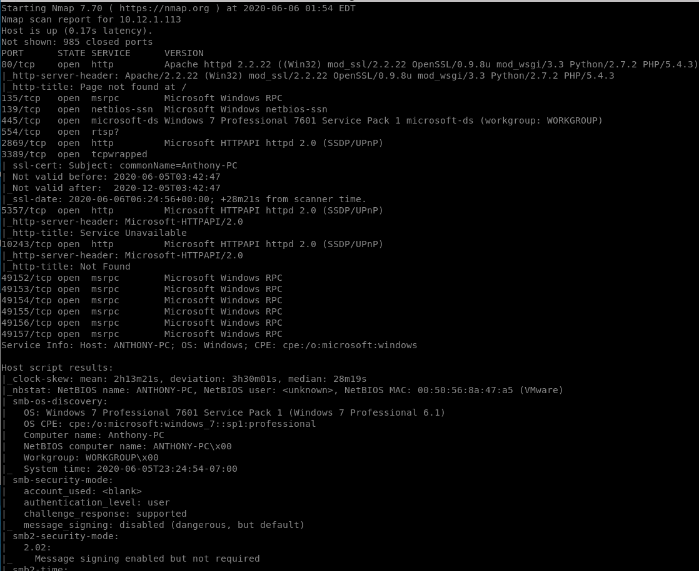

Let’s run an nmap scan. Immediately, we can notice SMB is on this system.

Exploitation

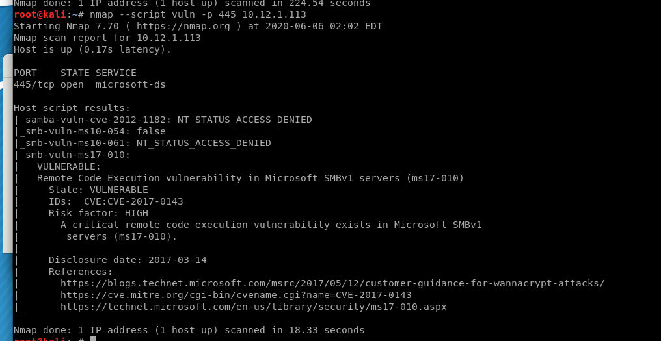

If we run a script to check for vulnerabilities, we can find it is vulnerable to ms17-010.



From here, we can choose the metasploit module related to ms17_010

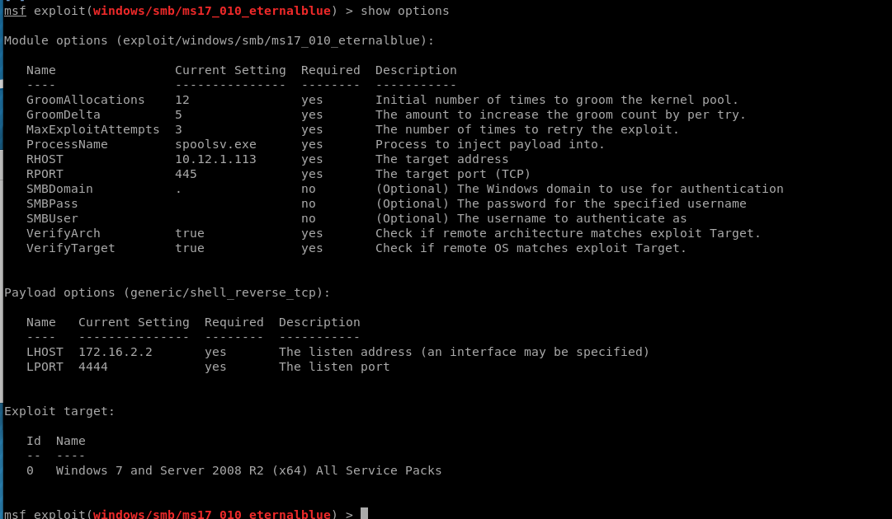

Set rhost to the IP and exploit

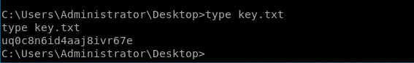

Navigate to C:\Users\Administrator\Desktop and type key.txt